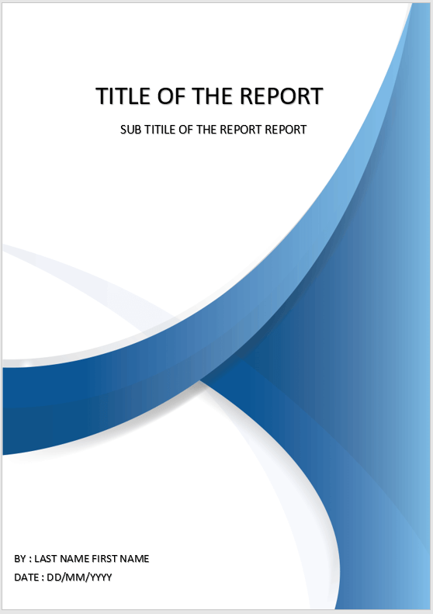

Report written by: (Steve) Yap Hou Yuen

Student ID: 19159521

Date: 11/11/2020

Professional Practice for Game Development

CMP4271

BSc (Hons) Computer Games Technology

Table of Contents

1. Abstract 3

2. Introduction 4

2.1. Teams and collaborations 4

3. Method 4

3.1. Participants 4

4. Online Employability Trading Game 4

4.1. What is the game? 4

4.2. Materials 5

4.3. Goals 6

4.4. Rules 6

4.5. Mechanics 6

4.6. Playtesting 6

4.7. Improvements and Reflections 6

5. Territorial Acquisition Game 6

5.1. What is the game? 6

5.2. Materials 7

5.3. Goals 8

5.4. Rules 8

5.5. Mechanics 8

5.6. Playtesting 8

5.7. Improvements and Reflections 8

6. Skill and Chance Game 9

6.1. What is the game? 9

6.2. Materials 9

6.3. Goals 9

6.4. Rules 9

6.5. Mechanics 9

6.6. Playtesting 9

6.7. Improvements and Reflections 9

7. (Rules) Strategic and Twitch skill Game 9

7.1. What is the game? 9

7.2. Materials 9

7.3. Goals 9

7.4. Rules 10

7.5. Mechanics 10

7.6. Playtesting 10

7.7. Improvements and Reflections 10

8. Play-testing 10

8.1. What is the game? 10

8.2. Materials 10

8.3. Goals 10

8.4. Rules 10

8.5. Mechanics 10

8.6. Playtesting 10

8.7. Improvements and Reflections 10

9. Discussions 11

9.1. Limitations 11

10. Reflections on acquired & required skills for Employability 11

11. References 12

12. CV & LinkedIn 12

13. Checklist: 12

# Abstract

This course module aids students in terms of developing professional skills as well as important academic values. Graduates will be required to work in different teams, project and time-management when discussing on a task and research verbal and written communication skills. These are the requirements a graduate would need to demonstrate during this course. To assist students in their developments, the module is delivered by using a problem-based learning approach. Each oncoming week students will join a different team to discuss upon a topic that relates to game industry or design. The rotating of teams for each week will help learn the importance of collaborations and compromising differing views as they work towards solving a problem.

# Introduction

## Teams and collaborations

For each week, students are separated into different teams to create and discuss on a game of their own. An hour is given to work on the given task whilst an additional 40 minutes is provided for game-testing. Once the timer is up, each team will present their ideas to everyone in the class using a PowerPoint presentation. The lecturer will give his thoughts, opinions and feedback to each group after their presentations has concluded. Moreover, after the session is over a 600-word draft report would need to be written and sent in on GitHub for feedback. This will be used in the 2000-word final report.

# Method

## Participants

There are 2 groups of participants that took part in this exercise. The first being participants of the group making and discussing on their game, and the other being students from other groups that provide their assistance during the game-testing period. There were some instances where groups would take longer than others to work on their project thus not being able to play-test their game and get feedback from other groups. This is where internal play-testing comes into play. Where the group themselves test their own game, find any flaws or issues and give their own feedback on the matter. Instances such as these occur when there is conflict between the team members on an idea or the lack of members in the team. Having the feedback of other teams are beneficial as it will help provide additional feedback and opinions in which the team could not identify as they came up with the idea.

# Online Employability Trading Game

## What is the game?

The theme of the game had to be associated with employability. The employability game is playable for 2-6 players. Players can choose to either play individually or separate into teams. Players/Teams will begin at the starting line. They will each roll the dice to determine who goes first (higher number wins). They will move along the board collecting skill cards. The game ends once both teams reach the end. However, to win the game, one must have a greater number of skill cards compared to opposing players/teams.

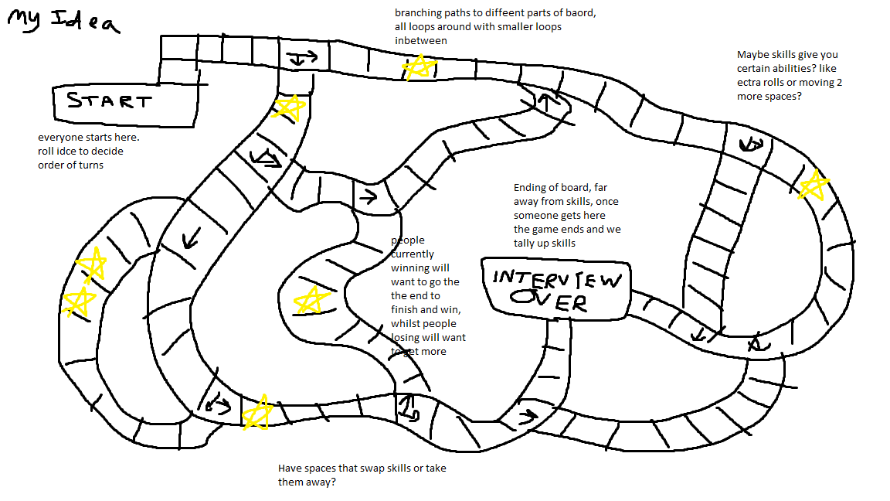

*Figure 1: Rough sketch of the playing board with annotations of instructions*

|  |  |  |  |
| --- | --- | --- | --- |
| Analysis  Skill | Communication skills | Teamwork | Experience |
| Ability to learn and evolve | Passion | Excellent oral communication | Programming Skills |
| Mathematical skills | Creative problem-solving skills | Time management skills | Hygiene |

*Figure 1.1: Examples of Skill Cards implemented into the game*

## Materials

* 2 dices
* 20+ skill cards
* A playing board
* Job cards and descriptions

## Goals

The goal of the game is to acquire as many of the listed skills before reaching the end of the board.

## Rules

* Only a single type of skill can be obtained by a player/team
* Upon landing on a ‘Lose a skill’ space, a random skill will be removed from your inventory
* Landing on a ‘Skill space’ allows players to gain a random skill
* Players may not receive the same card twice (unless the card has been lost before)

## Mechanics

Upon starting the game, the mission is to attempt to get hired from the chosen job. New jobs will be appointed every new game. Players move along the board by rolling a pair of dice. The trade option allows players to trade cards with opposing teams to benefit one another and making it easier to reach the end. The trading mechanic makes players more strategic in their plays as well as it being a win-win situation.

## Playtesting

Neither internal or external playtesting was conducted due to the lack of time.

## Improvements and Reflections

Plans to make it so that specific jobs will require specific skills that players will need to gather. Since it was the first week, it was difficult to converse and work with other team members as we were all new. This made discussions taking up a longer time span which led to lack of time for any playtesting.

# Territorial Acquisition Game

## What is the game?

Territorial Acquisition Game (TAG) is a tile-based conquest game playable by 2-4 players. The objective of the game is to attack other players, claiming as many tiles and destroying other capitals. There are various game modes in which players may battle it out.

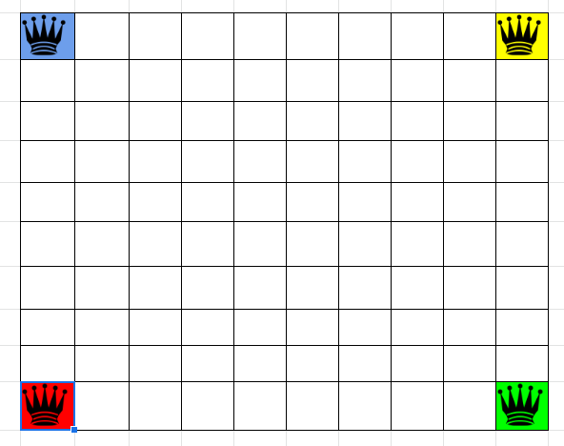

*Figure 2: Figure above shows the created play-board. The 4 corners with different coloured crowns signify where each player will start.*

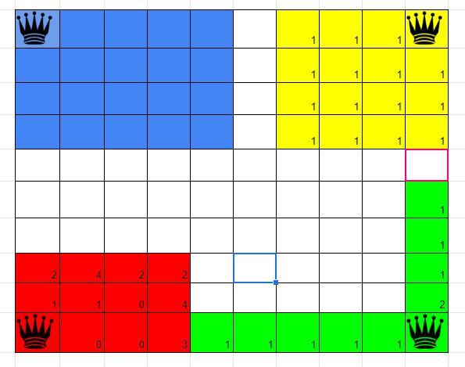

*Figure 2.1: Figure shows a vague gameplay. The coloured boxes indicate that that tile has been occupied by a player. The numbers in the boxes shows how many units are placed in that tile.*

## Materials

* A playing board
* Coloured tiles to signify a player’s domain
* A token system
* Units to be placed on the acquired tiles

## Goals

The goal of the game is to simply conquer as many tiles as possible before the number of turns to the game ends. An alternative to win would be to take over other capitols.

## Rules

* At least 1 unit has to be placed on a tile when that tile has been acquired
* The maximum number of units that can be placed on a conquered tile is 5
* To take over an opponent’s tile, the number of units must accede that of your opponents
* A dice will be rolled if players want to engage with one another with their number of units being the same amount, the player that rolled a higher number wins that tile
* Players are out if all their tiles have been consumed or if their capitol has been destroyed
* Each unit can only move 1 tile per turn
* Every 3 tiles owned by a player will grant a bonus token

## Mechanics

A ‘Token Unit System’ is used in the game. This essentially means that each player gains 1 token at the start of each round. Players will spawn in their capitols before starting the match. The capitol is the main source that provides players with 2 additional tokens each round. Units can be purchased through the spending of tokens. The map size can be changed (default size is 10x10). Moreover, the number of turns of the game can also be altered (default number of turns is 30 turns).

## Playtesting

Internal playtesting was carried instead of external. This was due to the lack of team members and most of the time was used up on brainstorming, designing and setting up the ideas. During the testing phase, the team scoped out that it is rather difficult to keep track of how many tokens and units each player has in their arsenal.

## Improvements and Reflections

A GUI will be implemented to counteract the issue of players finding it difficult to keep track of their information. Although the team lacked in numbers compared to other teams, we managed to discuss and give our differing views on the idea and set things up smoothly

# Skill and Chance Game

## What is the game?

The created game is based off of ‘Noughts and Crosses’, with the inclusion of a ‘Chance mechanic’. The board of the game is similar to that of Noughts and Crosses. As the game progresses, players will spin the wheel containing different events that will be implied into the game each turn. A player wins by getting 3 of their symbols in a row.

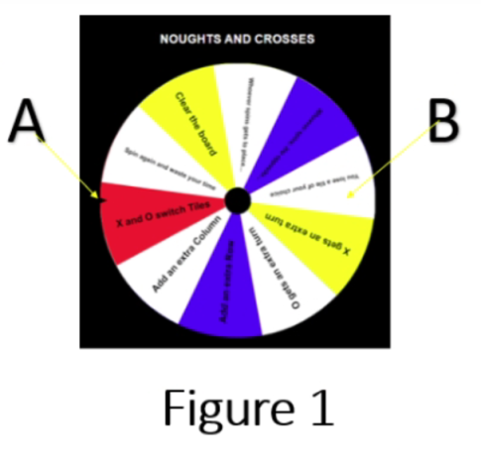

*Figure 3: Spinning wheel containing different events. [A] is a counter that determines an event after spinning the wheel, [B] is an example of an event.*

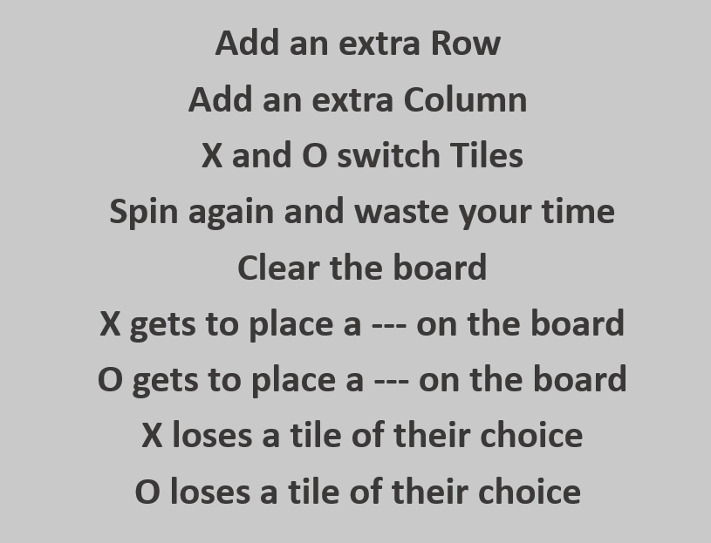

*Figure 3.1: Example events that will be on the spinning wheel.*

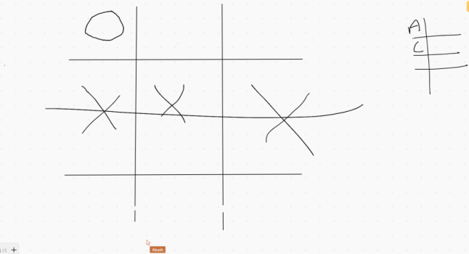

*Figure 3.2: Example of gameplay. After both players marked their spaces, they spun the wheel. Player [X] got an event of “extra turn” whilst Player [O] got an event of “lose a turn”. Therefore, showing how Player [X] won the game in that fashion.*

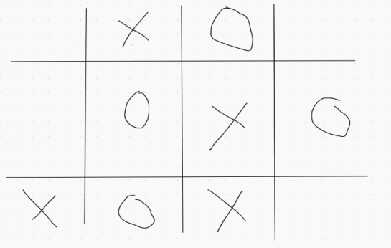

*Figure 3.3: The game ended in a tie as both players spun the wheel and got duds. Also, an event of “add an extra column” was made which is why the board looks like the above after the game ended.*

## Materials

* Blank piece of paper
* Pencil
* Ruler (optional)
* Spinning wheel
* Different events on the wheel (can be written on stickers and stuck on the wheel)
* A coin (to determine who starts)

## Goals

The goal of the game is as simple as it gets; try to win. However, the winning condition of the game may vary as the luckier player will potentially come on top.

## Rules

* Can only be played by 2 players
* A coin is flipped to decide the starting player
* The grid will start at 3 x 3 at the beginning of every match
* Players will decide amongst themselves on their symbols [X] & [O]
* First player to get 3 in a row wins the game
* If all the squares are occupied, the game will end in a draw

## Mechanics

As the game begins, both players will place their symbols on the board. After that, the player who went first will begin spinning the wheel, followed by the next player. As soon as an event has been chosen, it will immediately apply to the game. It is the “Chance mechanic”. This is because you have a 100% chance to land on 1 of the events. Moreover, you have a chance to land on a beneficial event or an event that ruins your chances of winning.

## Playtesting

The team managed to complete both internal and external playtesting. Internal testing came first as the team spot out some issues to tweak before having others try the game. We found that the game ended too quickly due to some of the events on the wheel. This was due to the fact that players may get lucky and get beneficial events whilst the opposing player will get unlucky with their events or be unable to counter because of the other player’s events.

## Improvements and Reflections

The events on the wheel may need to be tweaked as some are overpowered and some that do not help the players as much. A survey should be made and given out the players for feedback. This is to help the team have a wider knowledge of what should be implemented and what should not be. Reflecting on the game itself, there were mixed opinions. Whilst testing the game, players were very happy with how it went but some did not find it that amusing. This was the cause of some of the events being too 1-sided. The game is luck-based, which everyone understood. Therefore after each game, there were no hard feelings as one player just got luckier compared to the other.

# (Rules) Strategic and Twitch skill Game

## What is the game?

The game consists of players trying to work their way through obstacles to defuse a bomb under time constraints. The type of game created by the team is that there will be different questions ranging from 3 difficulties in each stage. By correctly answering questions, players will be able to proceed onto the next stage. Upon reaching the final stage, answering as many questions correctly in the remaining time limit will defuse the bomb.

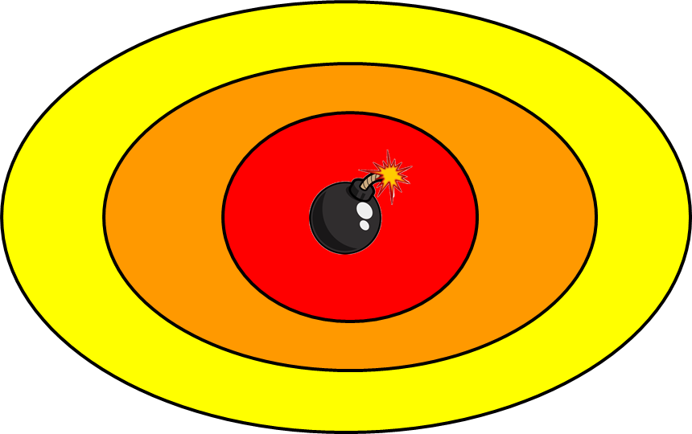

*Figure 4: An image portraying how the playing board will look like. Yellow area (level 1) is the starting stage with easy questions. Orange area (level 2) contains medium questions. Finally, the red area is the final stage consisting of the hardest difficulty questions.*

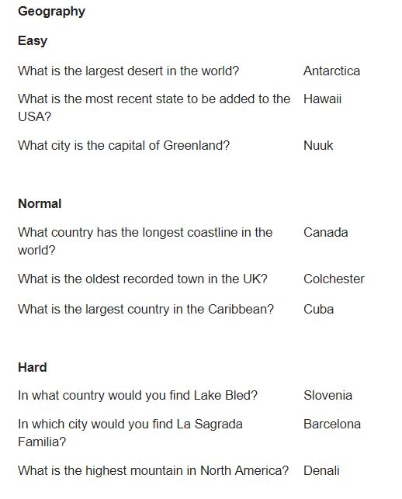

*Figure 4.1: A sheet showing Geographical questions and answers in 3 different difficulties.*

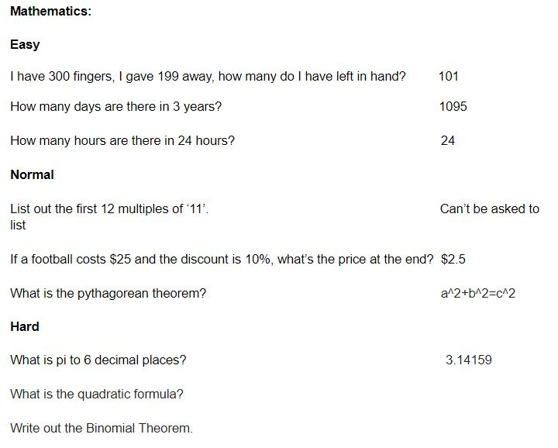

*Figure 4.1.1: A sheet showing Mathematical questions and answers in 3 different difficulties.*

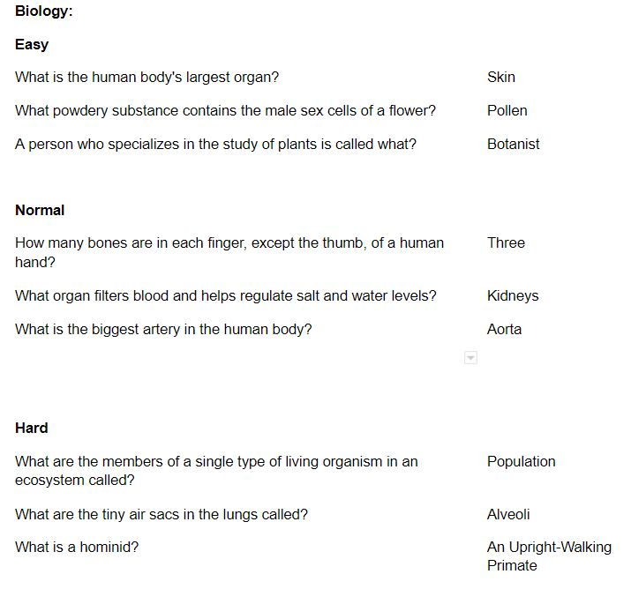

*Figure 4.1.2: A sheet showing Biological questions and answers in 3 different difficulties.*

## Materials

* Timer
* Question cards
* A playing board

## Goals

The goal of the game is to answer questions correctly in each stage to reach the final level to diffuse the bomb. Note that to defuse the bomb, several questions needs to be answered in the final stage to win.

## Rules

* Teams consisting of 1-4 players are needed to start to the game
* Duration of the game is 8 minutes long
* Correctly answered questions will award 5 additional seconds to that team’s countdown

## Playtesting

During internal playtesting, the team found that answering 2 questions correctly in the final stage would be too easy in the sense that players would know the answers immediately to the question. With that, the team changed it so that teams would need to answer as many as they can in a set amount of time. By making this change, it promoted the fact that teams will unlikely end in a tied game. Positive feedbacks were given during external playtesting phase. This informed us that the questions the team came up with were perfect for each category and difficulty.

*“The questions themselves were quite good and broad”*

## Improvements and Reflections

For future developments, more stages could be added as well as a feature to attack other teams. This is so that the game can inherit a more strategic-based playstyle as well. The current game received a lot of positive feedback and other teams enjoyed the game which tells us that there were little to no flaws.

# Play-testing

## What is the game?

The team was tasked to choose a game from the given list and playtest on it. The game chosen by the team is titled “The Great Flu”.

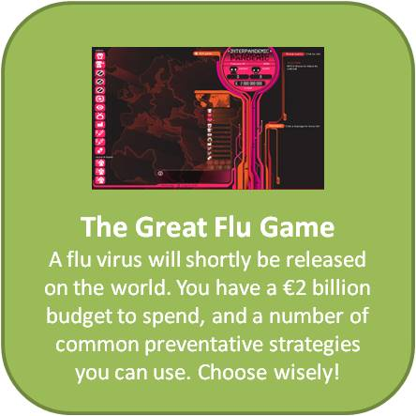

*Figure 5: Brief description on “The Great Flu” game*

## Game of choice and why

This game was chosen as it ties in with the current condition of our world as we are also facing the pandemic of Covid-19. Addressing the situation further and to acknowledge how it is very severe and we need to do what we can to contain it.

## Goals

The goal of the game is to contain a pandemic that the player has unleashed onto the world with a $2 billion budget. To achieve this, the player must strategize their public health moves in order to win the game

## Playtesting

It would have been beneficial if the team could have play-tested the game. However, this was not viable as the game is no longer in stores to access and therefore, resulted in the team taking what they can from the video provided. To add to that, there was only 2 videos (Part 1 & 2) on YouTube which the team took referencing from. Below is a link that was provided to view the game:

<https://www.youtube.com/watch?v=9a3bSlQLpnI&ab_channel=torteman54>

## Evaluations

First impression of the game did not provide enough information on how to play. Rather, it throws the player straight into the game without a tutorial. Moreover, the music is eerie and off-putting. During gameplay, it is unclear on what the player should do. Even after watching the gameplay of it, it is still unclear and messy.

## Questionnaire and responses

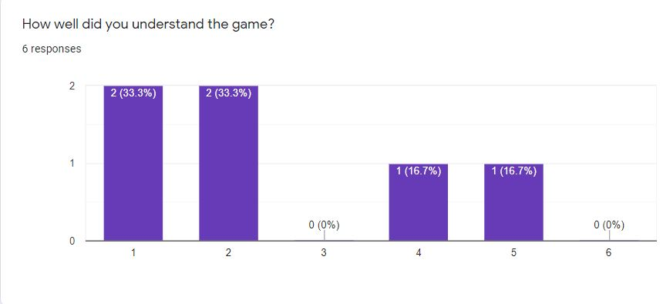

*Figure 5.1: Bar chart showing the percentages of how well players understood the game*

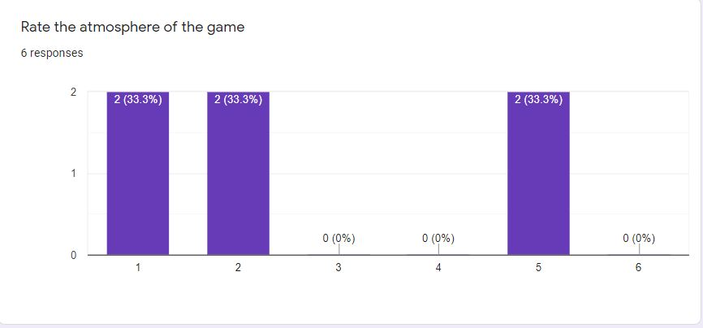

*Figure 5.2: Bar chart indicating the percentages of the atmosphere of the game*

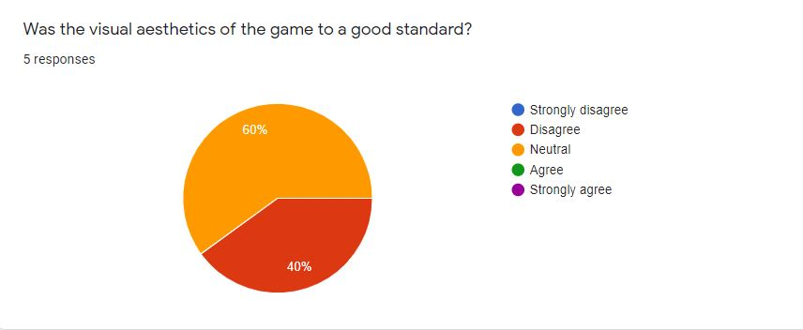

*Figure 5.3: Pie chart displaying the percentages of how well the aesthetics of the game were*

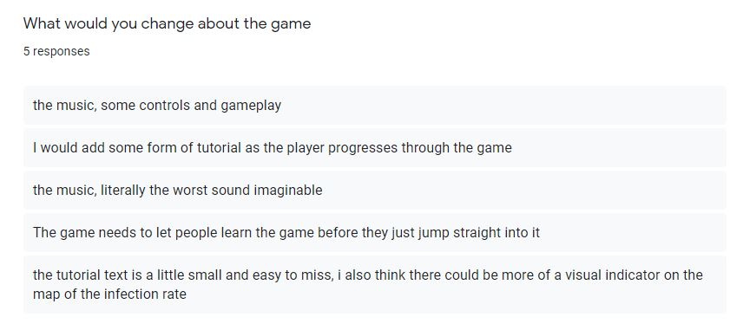

*Figure 5.4: Responses from players on the changes they would make to the game*

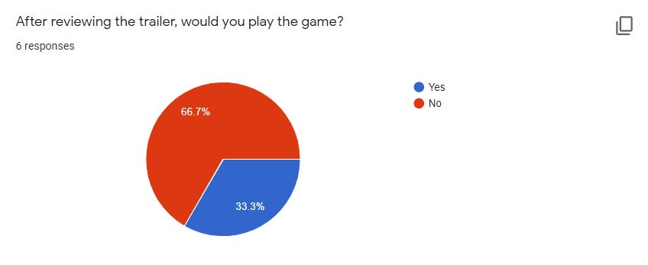

*Figure 5.5: Pe chart representing the percentages of whether players would play the game*

## Improvements and Reflections

More advanced questions could have been thought of as well as using different charts for each representation. The game should be reviewed by at least 20 players to get a better average of the results.

# Discussions

The key values each team should take away after each week’s discussions are different views of how to tackle the task, differing ideas, potential arguments and how to present to a crowd.

## Limitations

One of the issues faced during the play-testing periods was how some teams were unable to playtest their ideas with other teams. Although internal-playtesting was an option, it is best to have the opinions of others have a say at your game. The factor of ‘biasedness’ could come into play or it may not, so it is beneficial for others to give feedback on your game as well. Furthermore, different students have different backgrounds. What this means is that some have the knowledge to create games while others are just starting out. If by chance a team consists of every member not having experience in creating simple games, the team could be in shambles. Despite the teams being assigned randomly, students are still required to figure and work things out in the end and be ready for the presentation. In some instances, a team would consist of fewer members compared to other teams. Although this means that there will be less conflict in ideas, it will take longer to work through the task at hand. This will then promote the team to come up with a very simple idea to present to the class.

# Reflections on acquired & required skills for Employability

During the course of 7 weeks, I have gained and acquired many new skills that will benefit myself in future employability. Being in a different team consisting of different members each week has allowed me to learn and apply skills. The first of which is managing and leading the project. I sometimes propose my idea to the group and also give my thoughts and opinions if another has proposed theirs. Furthermore, on a few occasions I will allocate my members to work on their specific tasks in order to complete it accordingly and on time. To add to that, asking each member to present on the slides they worked on during the presentation is also part of how I am keen on managing my team. There are times when a member will disapprove of an idea, when that happens, we try to work things out and hear one another’s arguments and go with a final deciding vote on a final conclusion. We used this method so that there would be no hard feelings and conflict as it shows what the majority of the team wants to achieve. Overall, I have improved on my confidence levels in terms of proposing my own idea, arguing in the case of a conflict and presenting what we have done to the class. Also, being able to listen and understand the ideas and opinions of my team members has enhanced my capabilities in how I view thins. It has widened my thinking as I have gained more knowledgeable facts from each different member.

# References

Braithwaite B. (2008). Challenges for Game Designers. Delmar Publishing.

Schell, J. (2008) The Art of Game Design – A book of Lenses. Burlington, Elsevier.

https://awwapp.com/b/ubuyyuvatj5yd/#

# CV & LinkedIn

# Checklist:

|  |  |
| --- | --- |
| **Item** | **Completed ü** |
| I have read all of the assignment brief, its learning outcomes and marking criteria. I have clarified anything that I am unsure of with the module coordinator. | **ü** |
| I have attended all the taught sessions and completed my weekly online diaries and submitted to GitHubEducation via Moodle. | **ü** |
| I have been proactive in organising play testing sessions with my other classmates outside of my group. | **ü** |
| I have been proactive in getting to know my classmates. | **ü** |
| I have read the feedback on my online diaries, clarified issues with the tutor and acted upon the guidance. | **ü** |
| I have made sure my formal presentations are in an academic format i.e. objective, impersonal and in past tense which describes the work I have undertaken. | **ü** |
| I have submitted a report for pre-assessment, plagiarism check | **ü** |
| All work that is not my own is correctly referenced either in the report. | **ü** |
| I have taken on board the feedback, clarified any points I did not understand with the tutor and have acted upon the advice. | **ü** |
| I have uploaded all the required files in plenty of time to the correct module Moodle assessment point. | **ü** |
| I have worked to be a committed and active member of the team. | **ü** |
| I have engaged with my studies, read all the required reading and completed all the required tasks outside of formal class contact. | **ü** |
| I have clearly demonstrated a professional approach to my studies. All absences and non-submission of work has been discussed with the tutor. | **ü** |